Online Resources for English Learners (ELs)
Language Learning:​ It is important to practice reading, writing, listening and speaking everyday.
Use Clever to log into the sites in red.
Speak  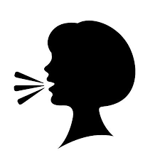 | Read |  |  | Listen  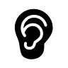 |  | Write
Duolingo  https://www.duolingo.com/  Free language learning app  Flipgrid- use username and password given by your teacher  www.flipgrid.com  Rosetta Stone- free resources during COVID19  https://www.rosettastone.com/freeforstudents/ | MyOn  Newsela  https://newsela.com/  PebbleGo  Tumblebooks – use username and password given by your teacher  https://www.tumblebooklibrary.com/Default.aspx?ReturnUrl=%2f  World Book Online  Unite Books  https://www.uniteforliteracy.com  - free app, no ads, no login, 40+ narration languages |  |  | Brainpop & BrainPop ELL – free resources for students during COVID19  https://go.brainpop.com/COVI D19  CBC Kids News  https://www.youtube.com/chan nel/UCWUA2W6LueNy9BSovi vFVvQ  Storyline Online  https://www.storylineonline.net/  TEDEd  https://ed.ted.com/  Starfall  www.starfall.com |  | Microsoft Office 365 for grades 3-5  www.office.com  Seesaw for grades K-2  Typing Club  https://www.typingclub.com/  Typing.com
Reference Materials:​ Tools to help you study, understand assignments, and stay organized.
English Dictionary  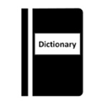 |  | Bilingual Dictionary  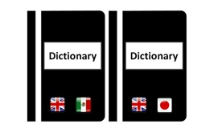 | Text to Speech & Speech to Text  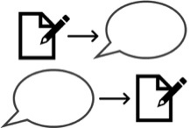 |  | Organize  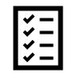
Cambridge Dictionary  https://dictionary.cambridge.org/us/  Dictionary.com  www.dictionary.com |  | Google Translate  https://translate.google.com  Word Reference - word to word translation  https://www.wordreference.com/  Bilingual Glossaries  https://research.steinhardt.nyu. edu/metrocenter/resources/glossaries | Natural Reader​ - reads text aloud https://www.naturalreaders.com/  Free Speech to Text Website  https://dictation.io/speech |  | Grade Level Class Pages & Calendars  https://rockledgees.pwcs.edu/cms/One.aspx?portalId=410485&pageId=3211160  PWCS Home Learning Page with Sample Schedule  http://www.pwcs.edu/cms/One.aspx?portalId=340225&pageId=41506907  Set daily/weekly goals and create a to-do list  Create a study space and a schedule
Wellness:​ Take care of yourself and your family. Stay healthy and reduce stress.
- Take brain breaks and engage in physical activity - Go Noodle ​https://www.gonoodle.com/

- The National Child Traumatic Stress Network
www.nctsn.org/resources/parent-caregiver-guide-to-helping-families-cope-with-the-coronavirus-disease-2019
- Healthy Children.org
https://www.healthychildren.org/english/health-issues/conditions/chest-lungs/pages/2019-novel-coronavirus.aspx
- National Association of School Psychologists
https://www.nasponline.org/resources-and-publications/resources-and-podcasts/school-climate-safety-and-crisis/health-crisis-resources/talking-to-children-about-covid-19-(coronavirus)-a-parent-resource

